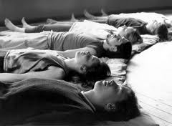

i Rest Yoga Nidra Workshop
Join Dr. Wu for a deeply relaxing practice of i Rest Yoga Nidra or meditation. Founded by Richard Miller, PhD. i Rest has many health benefits including:
*releasing negative emotions and thought patterns
*calms the nervous system, healing the body
*develops a deep capacity to meet any and all circumstances you may encounter in life

Through this process we are able to access inner healing and the pure awareness of being. Yoga Nidra is a powerful tool to eliminate stress, overcome insomnia, solve problems, resolve trauma, and neutralize anger, fear, anxiety and depression.

COMING IN MAY!!!
MORE INFORMATION TO FOLLOW!

Covington Yoga, 616 Main Street, Covington

